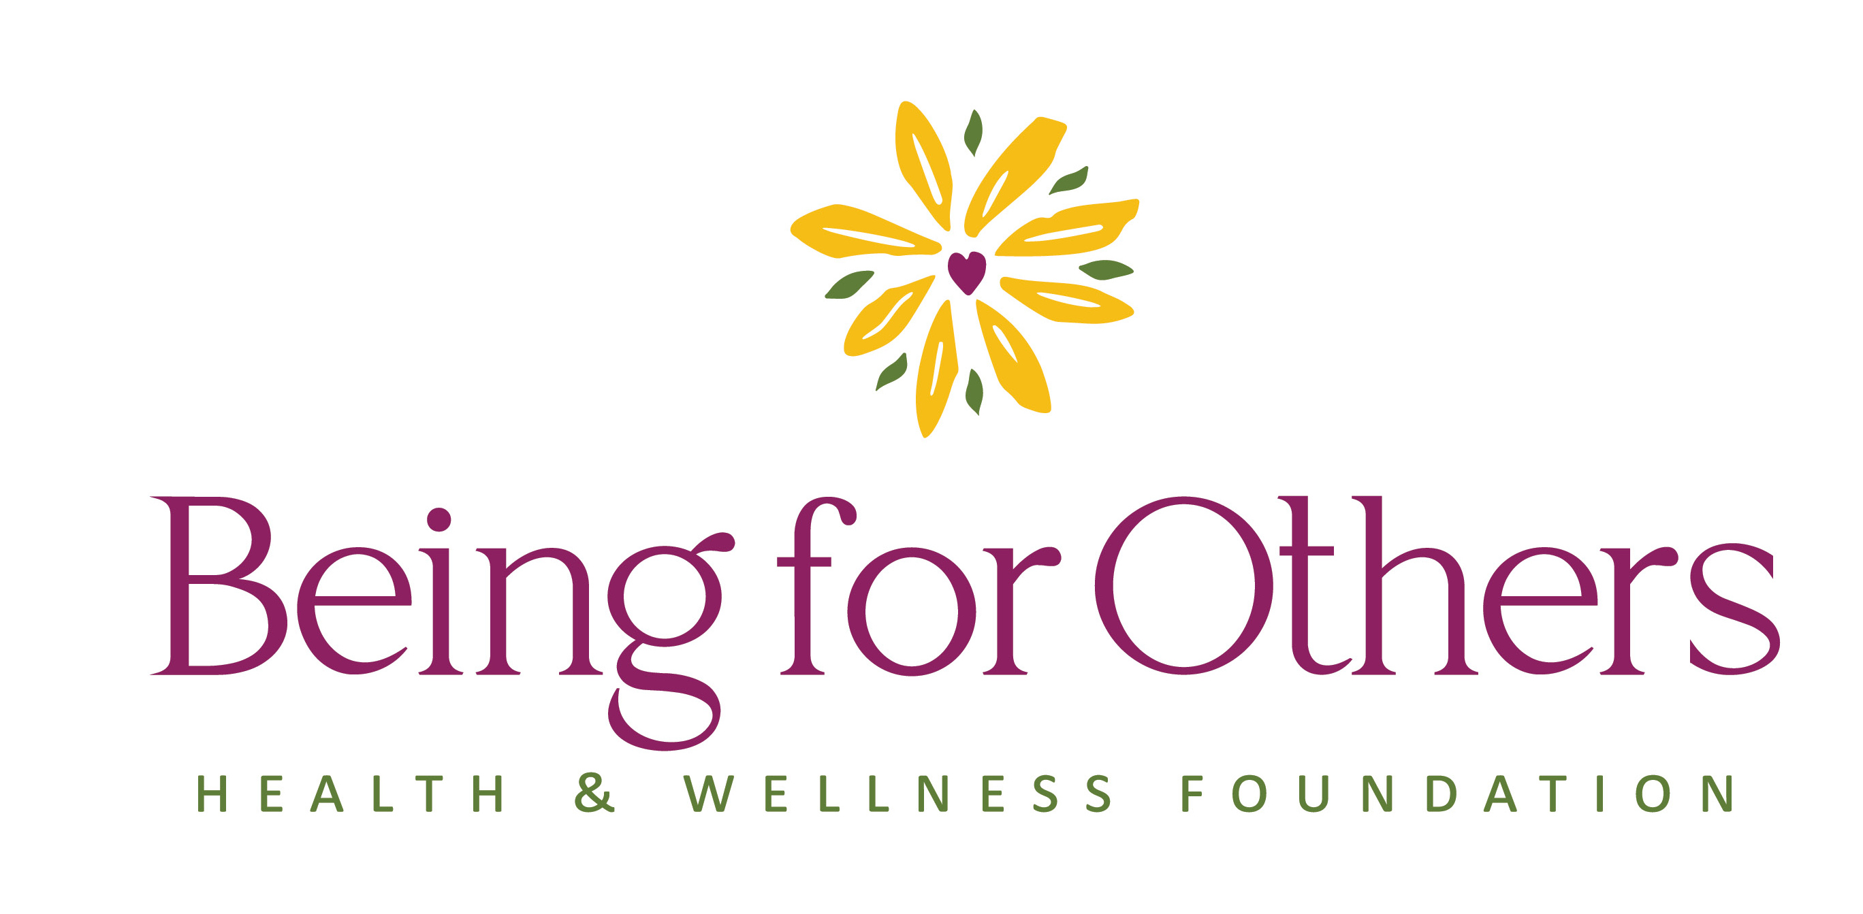
2026 Community Collaboration Grant
Letter of Intent (LOI) Form

SECTION 1 – ORGANIZATIONAL INFORMATION
Lead Organization Name:
________________________________________________________________________
Contact Person (Name, Title, Email, Phone): _________________________________
________________________________________________________________________
Organization Address:_____________________________________________________
Website: _____________________________ Year Established: ___________________
Organization Type:
☐ Nonprofit (Attach IRS Form 990 and Board of Directors list with submission.)
☐ Governmental Entity
☐ School

EIN: _______________________________________
Mission Statement:
________________________________________________________________________
________________________________________________________________________
________________________________________________________________________
Organizational Overview: (200 words max)
________________________________________________________________________
________________________________________________________________________
________________________________________________________________________

SECTION 2 – COLLABORATION OVERVIEW
Collaboration Title: ______________________________________________________
What community challenge(s) will this collaboration address? (150–200 words)
________________________________________________________________________
________________________________________________________________________
________________________________________________________________________
Provide evidence or data supporting the need for your collaboration: (Attach optional supporting documentation)
________________________________________________________________________
________________________________________________________________________
Has a community needs assessment been conducted?
☐ Yes (Attach the assessment or summary with your submission)
☐ No
Which BFO grant pillar does your Community Collaboration most closely address? (Please select only one pillar that best aligns with your project.) For detailed descriptions of BFO grant pillars, visit www.beingforothers.org/grants/pillars.
______________________________________________________________________________________
Explain how the pillar aligns with your project:
________________________________________________________________________
________________________________________________________________________
________________________________________________________________________
Counties served: List all counties within BFO’s eight-county region where your collaboration will have meaningful engagement — not just potential reach.
________________________________________________________________________
Primary county of impact: Which county will most directly benefit from the community challenge being addressed and why?
________________________________________________________________________
________________________________________________________________________
________________________________________________________________________
Populations most impacted: (e.g., youth, older adults, low-income residents, etc.)
________________________________________________________________________

SECTION 3 – COLLABORATION PARTNERS AND READINESS
List at least two committed partners: (include organization, role, and contribution)
- __________________________________________________________________
__________________________________________________________________
- __________________________________________________________________
__________________________________________________________________
- __________________________________________________________________
__________________________________________________________________
List additional prospective partners if applicable:
- __________________________________________________________________
__________________________________________________________________
- __________________________________________________________________
__________________________________________________________________
- __________________________________________________________________
__________________________________________________________________
Have these partners collaborated before? If yes, describe briefly:
________________________________________________________________________
________________________________________________________________________
________________________________________________________________________
Provide two community references: (Name, Organization, Email, Phone)
These should be individuals who can speak to your organization’s capacity, reputation, community relationships, and readiness to effectively lead a collaboration:
- __________________________________________________________________
- __________________________________________________________________

Indicate your current stage:
- ☐ Facilitation Stage – no structured facilitation yet
- ☐ Implementation Stage – facilitation completed and plan in place
- ☐ Both – ongoing facilitation and early implementation

SECTION 4 – PRELIMINARY BUDGET
Total anticipated project budget (3 years, all funding sources): _____________________
Anticipated BFO Request (up to $250,000 over three years): _______________________
List all potential or confirmed funding or in-kind support:
Funding Source | $ Amount | Secured, Pending, or In-Kind

SECTION 5 – SUMMARY STATEMENT
What is the primary goal of your collaboration and the change you hope to achieve? (150 words):
________________________________________________________________________
________________________________________________________________________
________________________________________________________________________

Submit the completed BFO Community Collaboration LOI and all required supporting documents by email to info@beingforothers.org no later than February 27, 2026.
Required attachments:
- IRS Form 990 and Board of Directors List (nonprofit organizations only)
- Community Needs Assessment or Summary (if applicable)
- Supporting Evidence or Data Documentation (if applicable)

